Learning Guide

Managing Material Planning and Actuals

25 October 2021



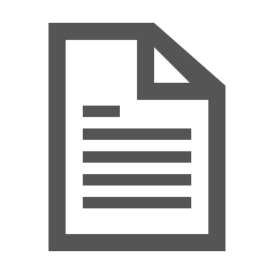

Table of Contents

Table of Contents 1
Introduction and Learning Objectives 2
Create a Route 3
Steps 3
Modify a Route 6
Steps 6
Delete a Route 8
Steps 8

Introduction and Learning Objectives

In Maximo, a Route is a list of related assets, locations, or both. The assets and locations are considered stops along the route also known as Route Stops in Maximo.
Routes can be used in the following ways:
- Apply the route to a work order and generate child work orders for each route stop
- Apply the route to a work order and generate a single work order that contains a list of assets and locations for all route stops
- Apply the route to a work order and generate task work orders for each route stop
- Apply the route to a Preventive Maintenance (PM) record. Then generate a work order for the PM that can have the Route stops as child Work Orders, a list of Assets and Locations, or Tasks on the resulting Work Order
A Route is used as a tool to help the people planning and scheduling work. Routes allow people to create and schedule the work more efficiently. They also provide planners and schedulers a way to efficiently plan and schedule work that is in the same area or are the same type of assets.

By the end of this Learning Guide, you should be able to:
- Create a Route
- Modify an Existing Route
- Delete a Route
Routes are created using the Routes (Oil) application in Maximo.

Create a Route
Follow the steps below to create a route in Maximo.

Steps
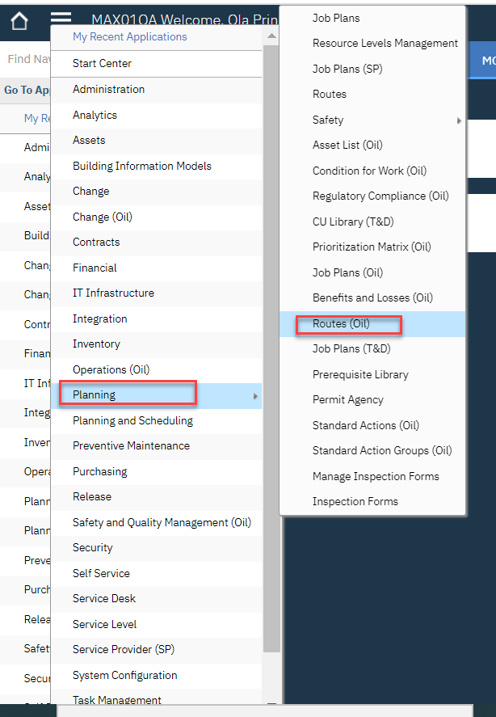
- After logging into Maximo, click the Go To icon, select the Planning option and then, select the Routes (Oil) application.

- In the Routes (Oil) application page, select the New Route icon.
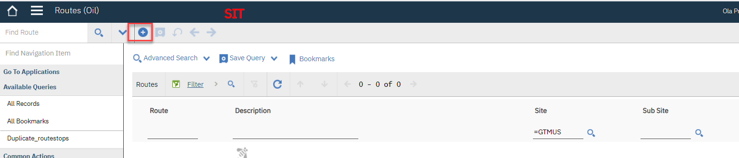

- Select a route option to specify the type of work orders to be generated when the route is applied to a work order.
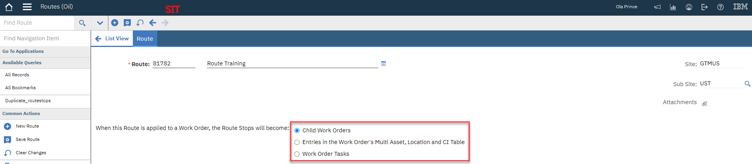

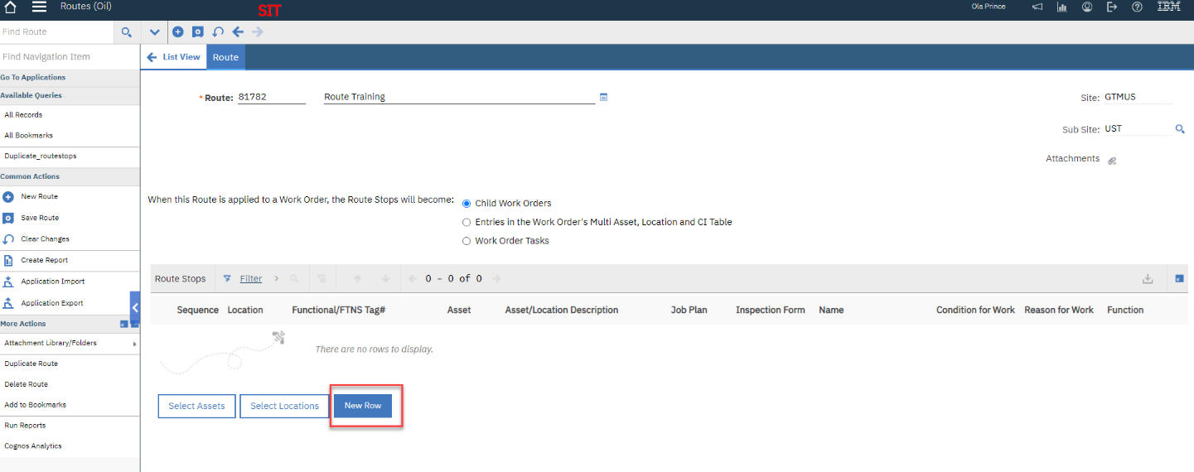
- Add Route Stops by clicking the New Row Button.

- Add Job Plan, Sequence, Location, Asset, and other fields as required.
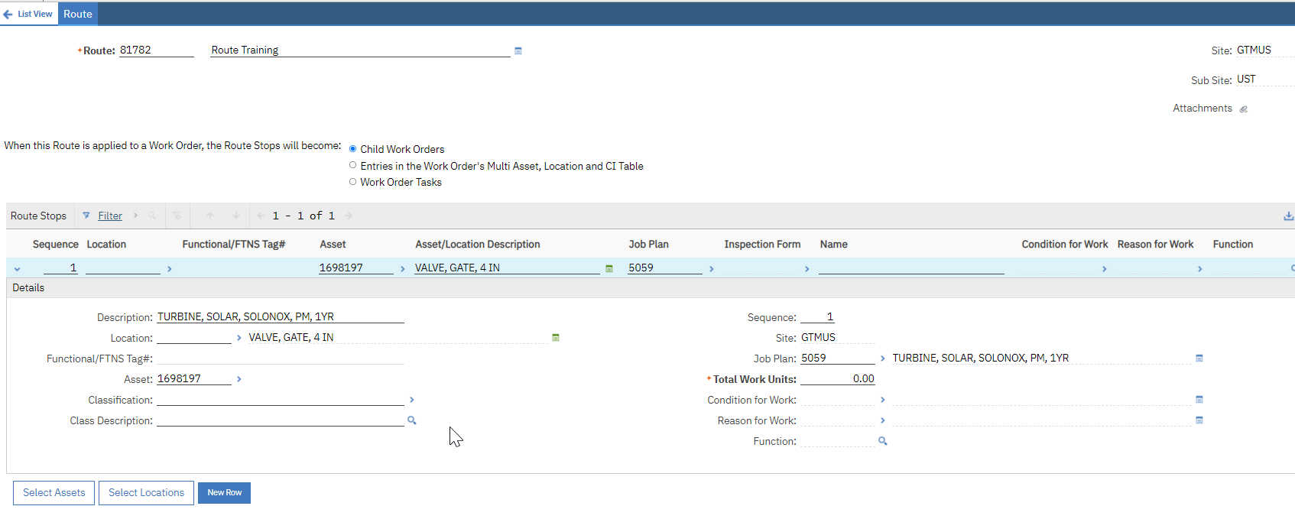

Note: Repeat steps 4 and 5 to add additional Route Stops as needed.
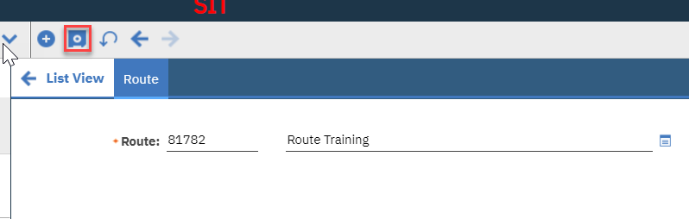
- Select the Save icon to complete the process.

Modify a Route
Follow the steps below to modify a route in Maximo.

Steps
- After logging into Maximo, click the Go To icon, select the Planning option and then, select the Routes (Oil) application.

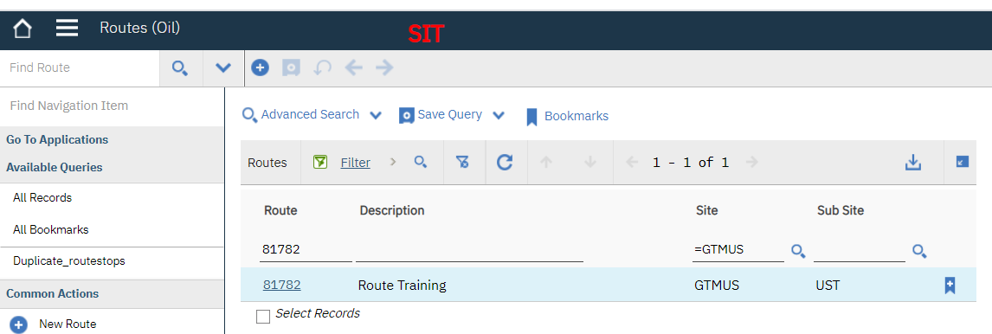
- Search for the Route that needs to be modified by entering the Route number in the Route field.

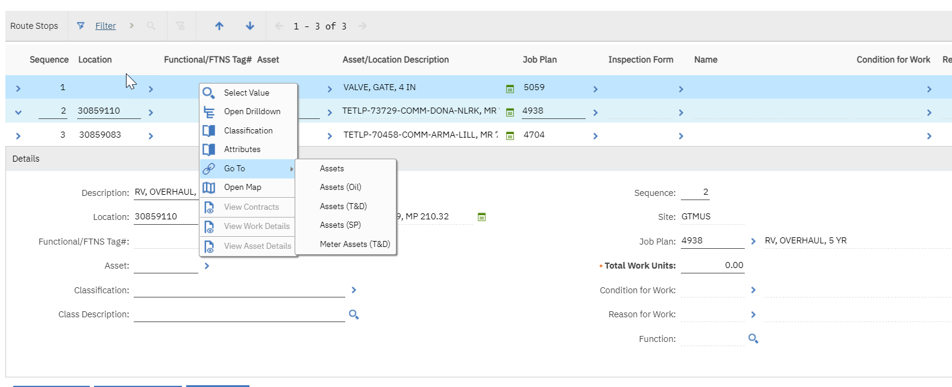
- Select a route stop and make a change as needed. For the purposes of this document, we are adding an asset on the Asset field.

- The Asset has been added to the route. Select the Save icon to complete the process.
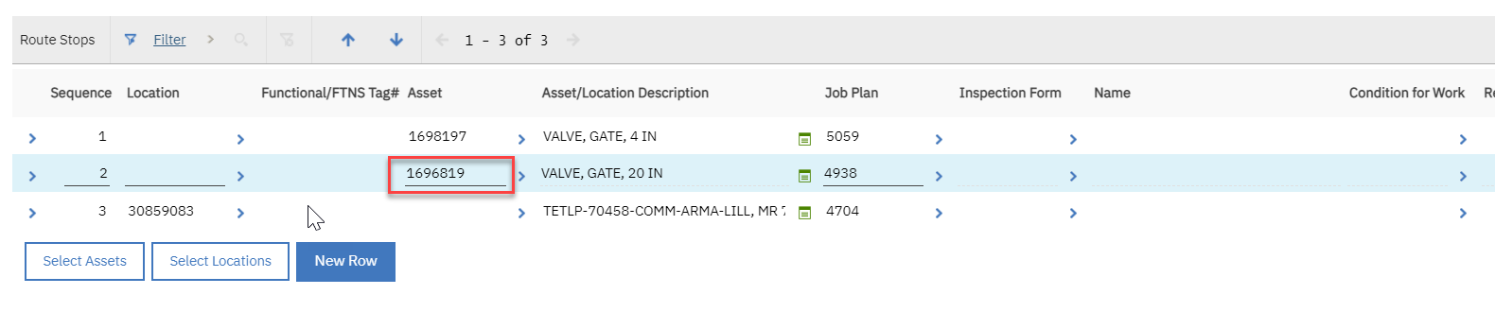

Delete a Route
Follow the steps below to delete a route in Maximo.

Steps
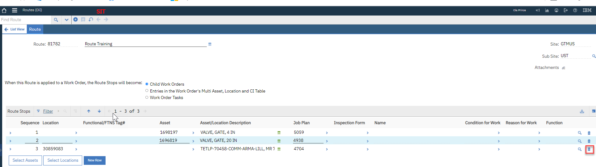
- Navigate to the route stop you need to delete and select the Trashcan icon.

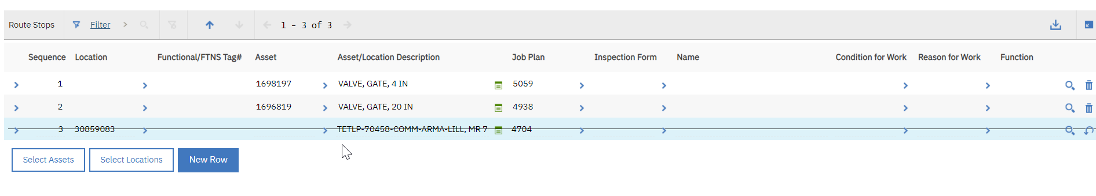
- Maximo strikes through the route stop you intend to delete.

- Select the Save icon to complete the process.

